Practical
SUMMARY:-
This practical demonstrated the implementation of Linear Search and Binary Search in C. It helped understand how both algorithms search for an element and compare their efficiency.

Linear Search checks each element one by one until the target element is found or the array ends.
Output
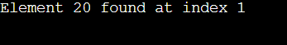

Binary Search repeatedly divides a sorted array into two halves to quickly find the target element.
Output
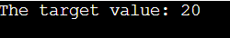

Conclusion
We learned that Linear Search works on any array but is slower, while Binary Search is faster and more efficient for sorted arrays.

